**Mini Project**

**(2020-21)**

**Mid-Term Report**



**Institute of Engineering & Technology**

**Submitted by:**

**Mani Singh (181500365)**

**Pallavi Solanki (181500445)**

**Shivendu Sharma (181500684)**

**Vikas Pandey (181500789)**

**Supervised by:**

**Harvinder Kaur**

**Department of Computer Science & Engineering**

**Contents**

**Abstract**

**1. Introduction ---------------------------------------------- 4**

1.1 General Introduction to the topic ---------------------- 4

1.2 Area of Computer Science ----------------------------- 6

1.3 Hardware and Software Requirements -------------- 6

**2. Problem definition -------------------------------------- 7**

**3. Objectives ------------------------------------------------ 8**

**4. Implementation Details -------------------------------- 9**

**5. Progress till Date & The Remaining work --------- 12**

**6. Some Screenshots --------------------------------------- 13**

**7. References** ----------------------------------------------------- **25**

**Abstract**

In this project we will build a E-learning website name StudyHub (The resources you need). This is a website which is design to help, support and enable B.Tech students of a specific stage to overcome their resistance and fear. The website limits not only up to internet but also it provides an admirable way to learn distinct stuff. This website consists video lecture, Quizzes and motivational quotation which help students to keep motivating towards their studies. This project mainly the development of a fully responsive, compatible, intuitive and interactive website. The project comprises of both front-end and back-end and it can store data and login details of its user once it is complete. This project is made in domain of web-development to make it available for each individual steadily and is only one search away.

**Introduction**

**1.1 General Introduction to the topic**

To build a StudyHub website we use all basic components which are required for web-development project. The web page uses HTML, Cascading Style Sheet (CSS) for its front-end structure. Bootstrap and j-query are used to make it responsive and certain animation and hover, click effects. CSS cards are design to display daily motivational quotes and useful tips.

Back-end of the website required all the basic tools and languages of back-end development. PHP and My- Sql database are the two major component. It can store data and login details of its user once registration is done.

**About StudyHub**

StudyHub is a project that is an e-learning platform for students of B.tech. This website delivers a wide selection of online courses for Btech students via the internet. It is very economical place to learn.

It aims to provide subject related videos; Motivational quotation and it has an inbuild quiz for testing skills. Its quizzes and motivational quotes keep on shuffling. StudyHub has all courses as far concerned to B.tech students.

**How it works and useful**

* This website consists of all the material (courses/subjects) which is require for B.Tech students.
* As it provides the Video lectures for all Subjects of B.Tech which help students in intuitive learning.
* This website consists of quizzes that will enhance the student confidence and check their learning skills.
* The website requires to register to reach the following website material.
* It provides a free resource access for learning in intuitive way.

**Basic ER Diagram**

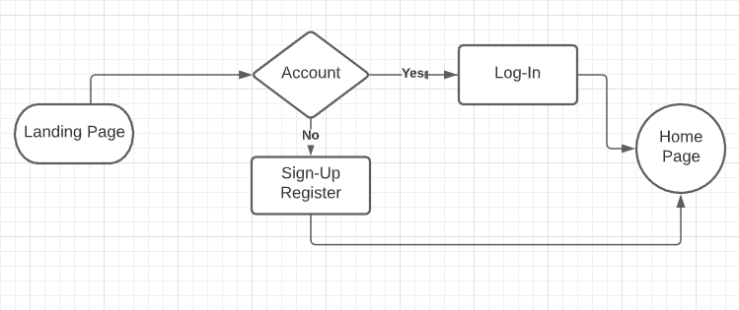

**1.2 Area of Computer Science**

StudyHub is a project that falls under Computer science, in domain of web-development. This project is mainly the development of a fully responsive, compatible, easy to use, and interactive website. The project comprises of both front-end and back-end of the website and it can store data and login details of its users once it is complete.

StudyHub is built keeping in mind that it would have many users who won’t be able to access this website all the time from their laptops or desktops, hence, this site is made fully responsive for their users and can be accessed from any device which have minimal and basic requirements.

This project is made in domain of web-development to make it available for each individual easily and is only one search away.

**1.3 Hardware Requirements**

* 1 GB RAM
* Laptop/Desktop
* External Backup Storage
* Internet Connection (Ethernet/Mobile Network)

**1.3** **Software Requirements**

* Brackets text editor (HTML text editor)
* WEB Browser (Chrome, web explorer)
* Graphic Editor (GIMP)
* FTP client (FileZilla)
* GitHub (progress report)

**Problem definition**

The problem that has lead to us to work on this project is easy availability of study material at single platform without any hustle. This site will gather resource with different sources on WEB and make it available at single platform. The problem seems to be complicated but it can be resolved if one gets all the material he requires for his subject and study purposes. With all the resources and a bit of motivation one can do miracles. Students now a days prefer to get their problems solved online rather than meeting someone face-to-face OR in-person. StudyHub focuses on this problem of modern world students and its main aim is to solve this problem. So, to this this problem we create a website where students easily access the resources they need.

**Objective**

The objective of this website is to help students in learn more and effectively from the resources of this website through internet. It consists the best material available on certain topics which contain lecture and e-learning videos, practice sheet all accumulate at a single place so an individual can use it intuitively. This is the only way to test the skill and level of the students and help us in providing them better stuffs according to their capturing ability.

**Implementation Details**

**Use case Diagram**

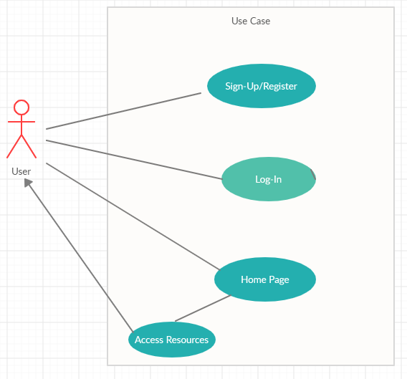

StudyHub is a website that uses all the basic components used by a website. To make it more user-friendly certain libraries and tools have been implemented.

**HTML**

The language provides the basic structure to the page. HTML rows and tables, containers,etc.

HTML tags , nested tables have also been used to benefit in less lines of code and ease of implementation

**CSS**

CSS divisions, nested divisions, margins, animations, and development of logos.

Animations and effects added to the page. The styling and spacing to the page, colour and texture. Cascading Style Sheet’s divisions, containers, nested divisions, margins etc. has been implemented to make the front end look interactive. The colour combination and texture that uses up the CSS libraries helps differentiate the text on the website and remain readable.

CSS margins, spacing and padding made the website available at the centre of the screen and blocked/hidden corners were minimized.

CSS text-decoration, font-family, font-colour, z-index etc. has also been implemented so to distinguish between the text and background.

**BOOTSTRAP**

Bootstrap libraries have been imported to the code in order to get responsiveness in the website.

Few of the Imported libraries are-

<https://stackpath.bootstrapcdn.com/bootstrap/4.5.2/css/bootstrap.min.css>

<https://stackpath.bootstrapcdn.com/bootstrap/4.5.2/js/bootstrap.min.js>

<https://stackpath.bootstrapcdn.com/font-awesome/4.7.0/css/font-awesome.min.css>

These libraries contain bootstrap.min css that helps making the margins and spacing expand and shrink according to the screen.

The bootstrap JS has been used to import some libraries of the java-script that has made to sort our content, loop, terminate, etc wherever required.

**J-Query**

Libraries of J-Query have been imported and implemented in order to give certain animations to the site. J-Query libraries provided certain animations to the buttons, hover effects, animations, hover effects, on-click animations etc. that has made the website more interactive and attractive.

One of the library is mentioned-

<https://code.jquery.com/jquery-3.5.1.slim.min.js>

J-Query makes the implementation of JavaScript easy and it is one of the reasons to use it in this site.

**LOGO / IMAGES / ICONS**

The logos used in this site have been custom created by CANVA and proper copyrights and credits have been kept in light.

Images have been taken either from google pictures or have been downloaded from bing (png is the only format used).

Icons in the sites have been taken from the source sites and legal use of icons have been followed.

**BACK-END**

This is the future of this website, it will use MySQL and PHP for Back-End development.

**HOSTING**

Free Hosting service provider is to be used to host this site on the internet.

A specific domain isn’t decided yet but hosting is to done on a free platform only.

**Progress**

The Front End of the Website has been almost created and only finishing is left.

The contents under the links are yet to be inserted.

Landing-page, Login and Registration page, Home page and, several hyperlinks of the Homepage are active.

There are certain links placed in the homepage that are yet to be assigned a hyperlinked page and these links are currently not working,

Work is being done to the inactive links and hyperlinked pages are being created.

Content-insertion, Social media Links, linking of Homepage to Login & Registration page, and Id Verifier is the task remaining on the front end of the site.

Back-End is to be developed in future, but certain parts of the website like Login, new user registration also uses Back-End development and that will be done by the end of this project.

**Screenshots**

Landing page

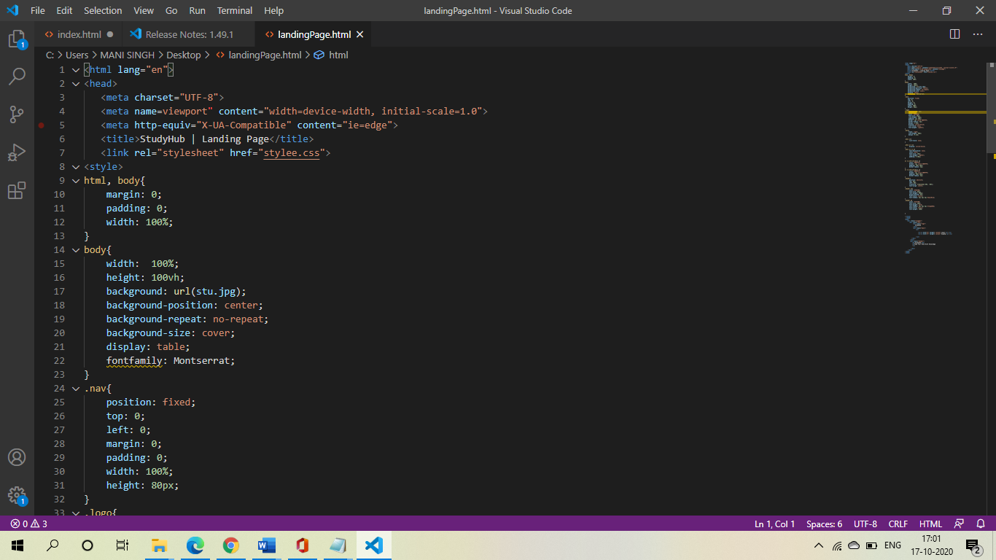

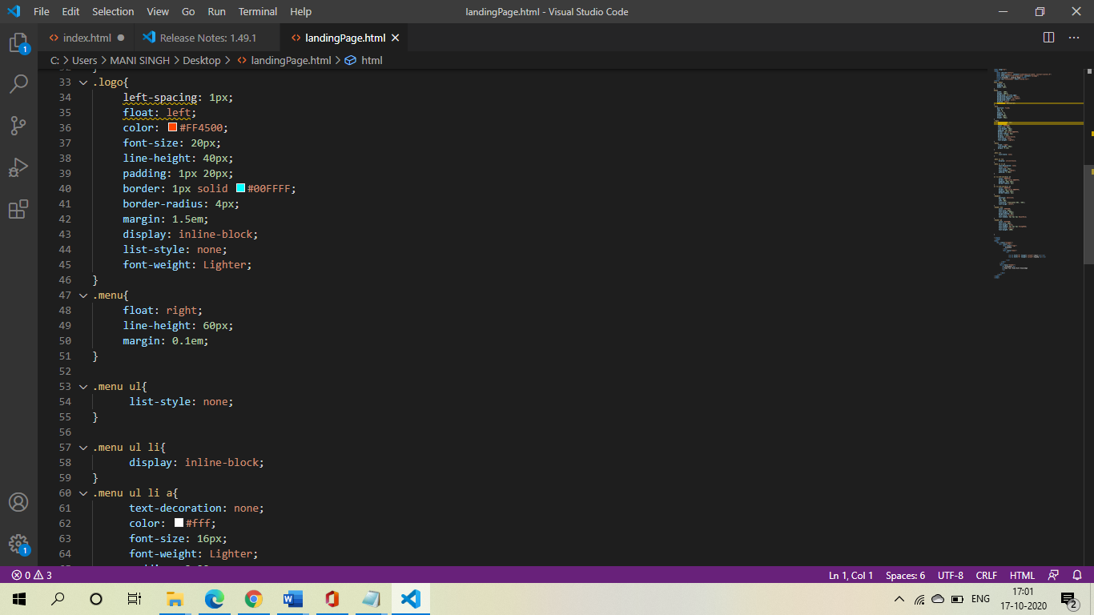

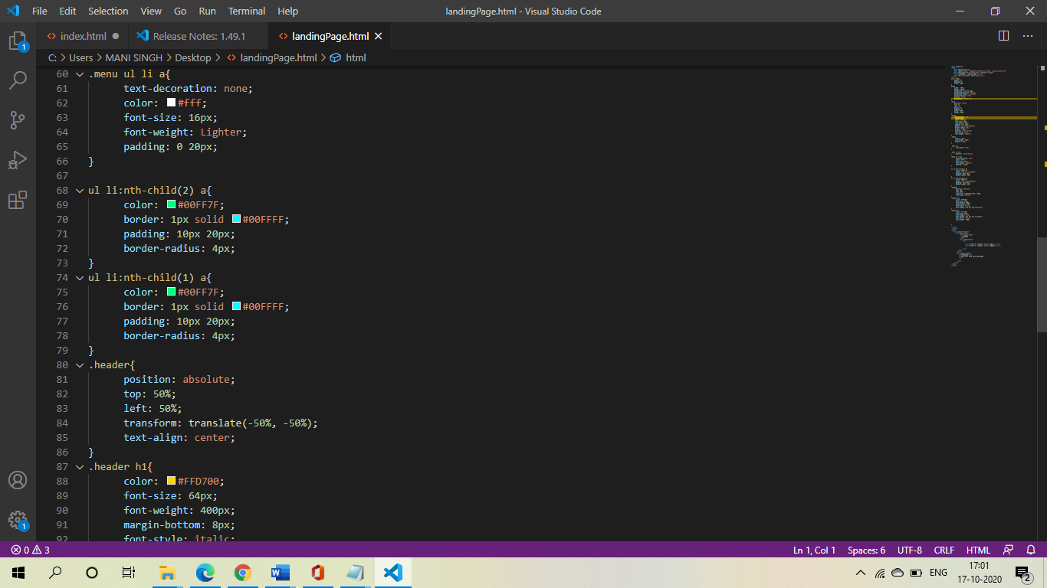

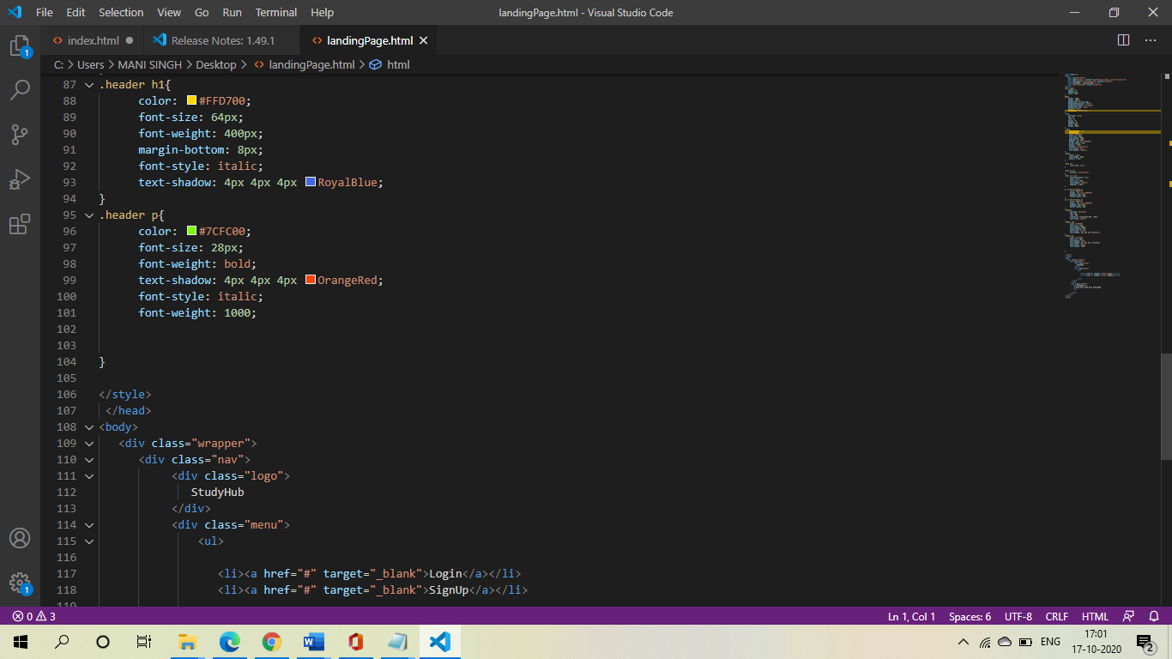

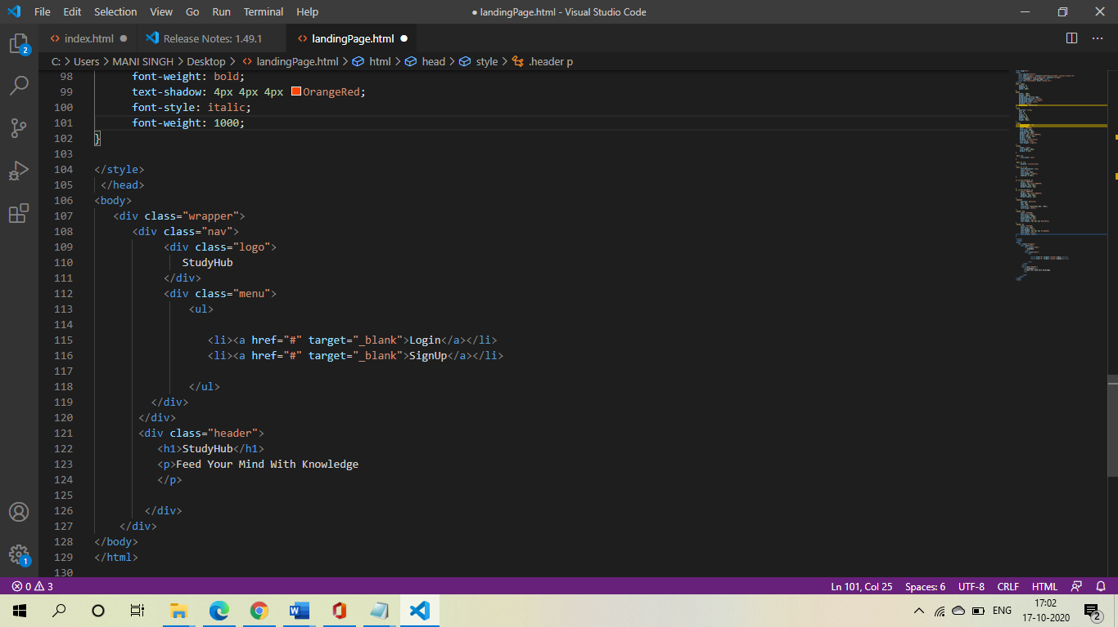

Log-In/Sign-Up

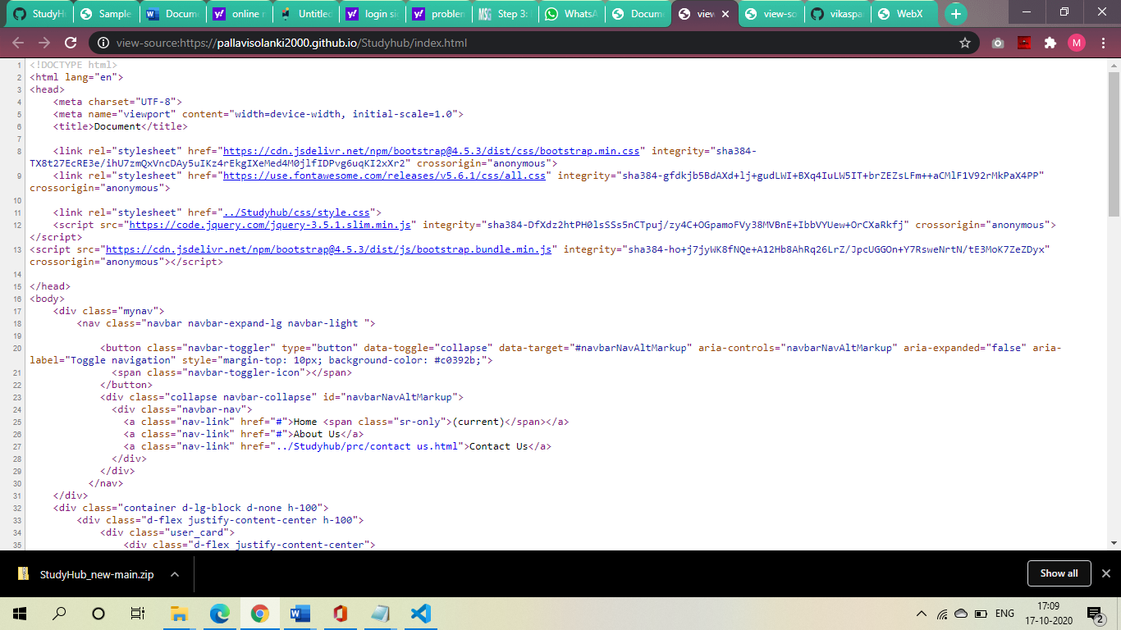

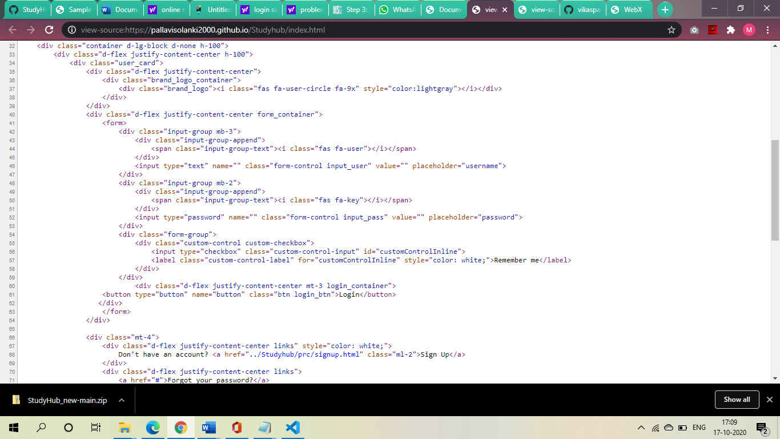

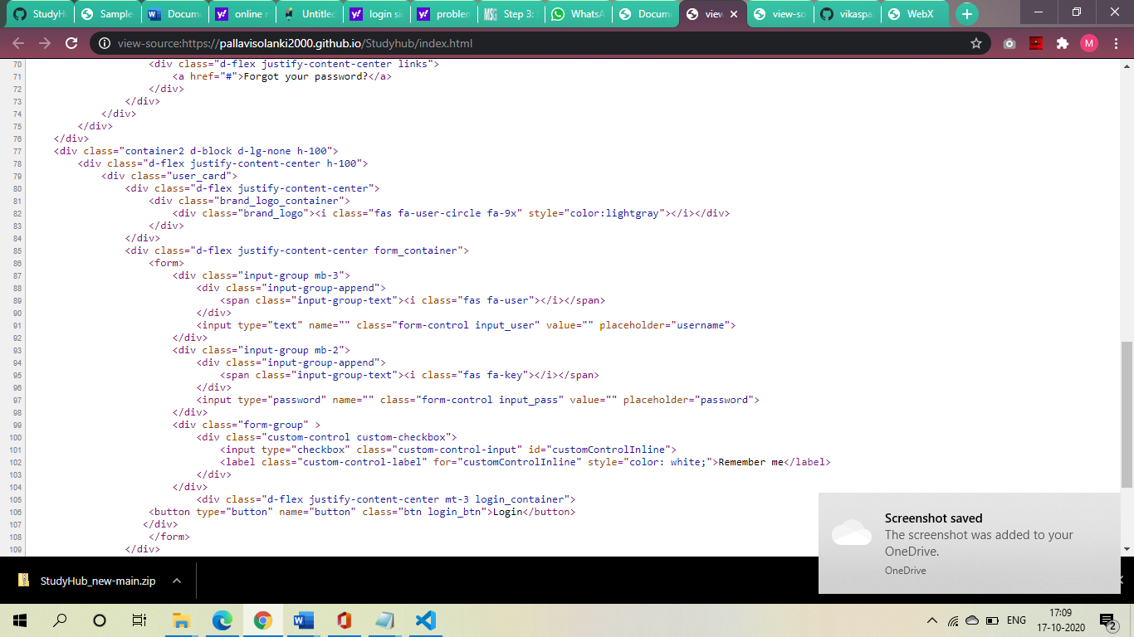

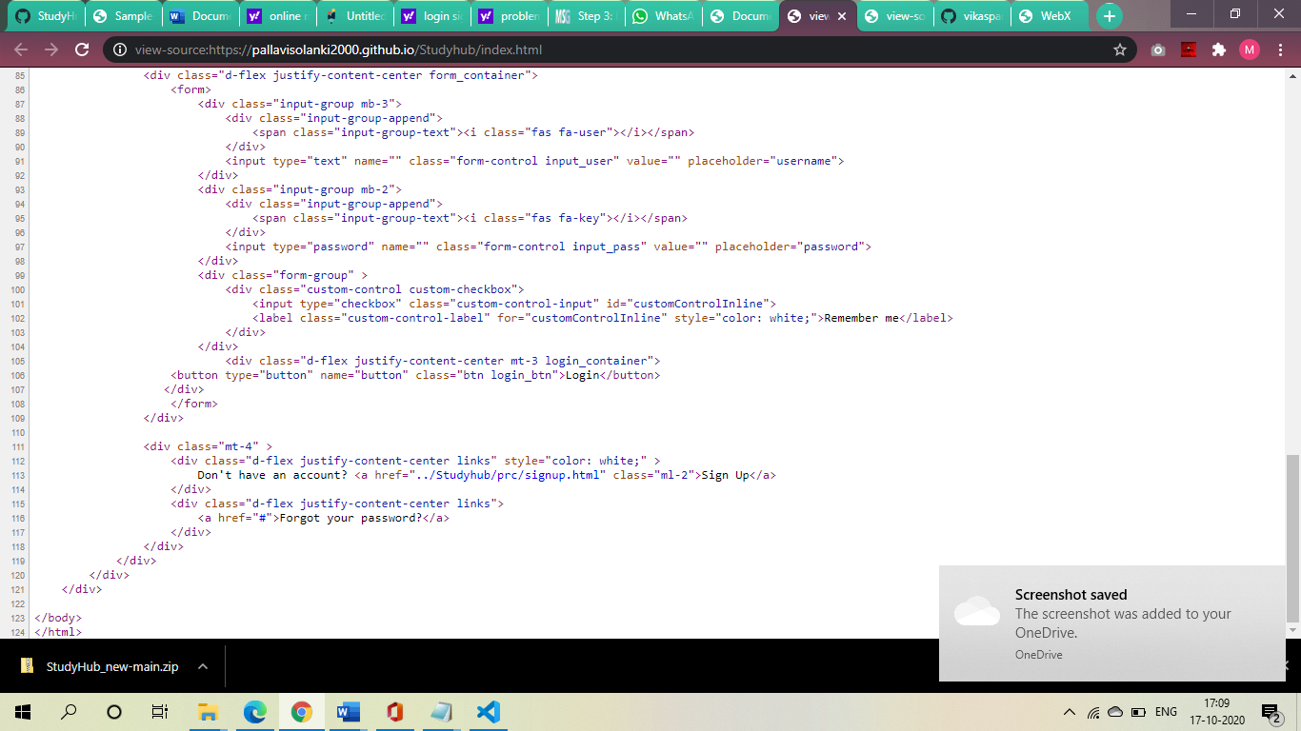

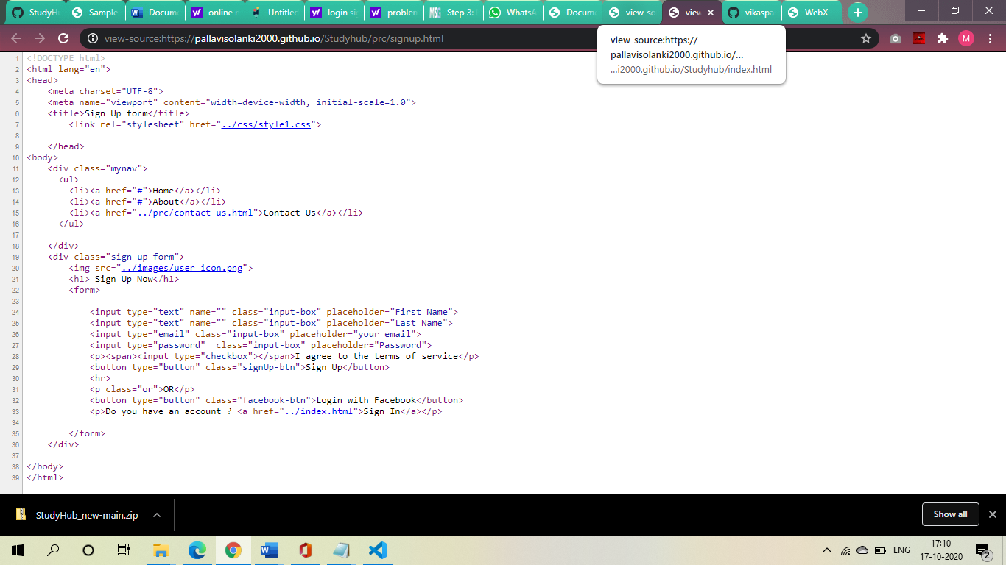

Contact us

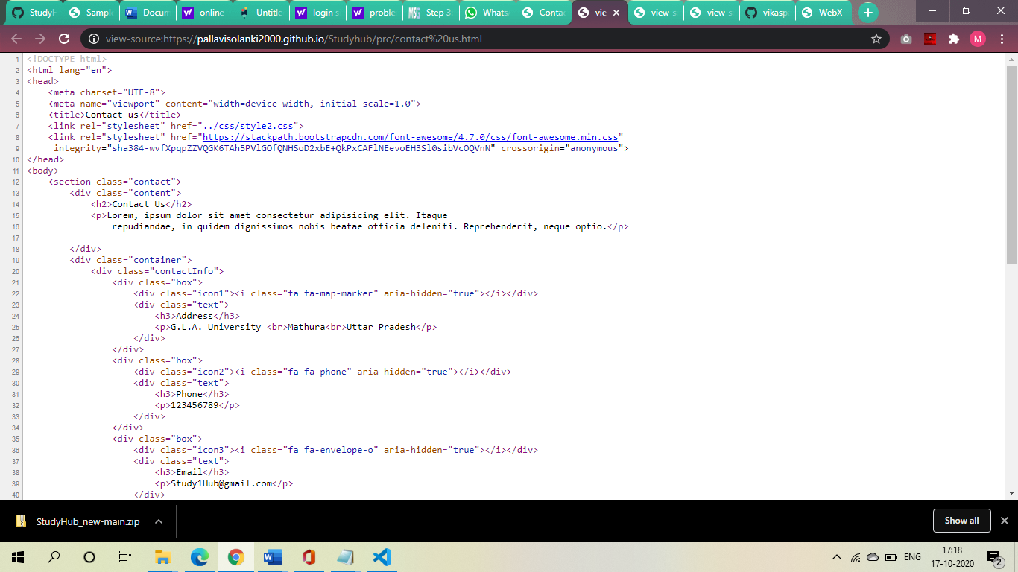

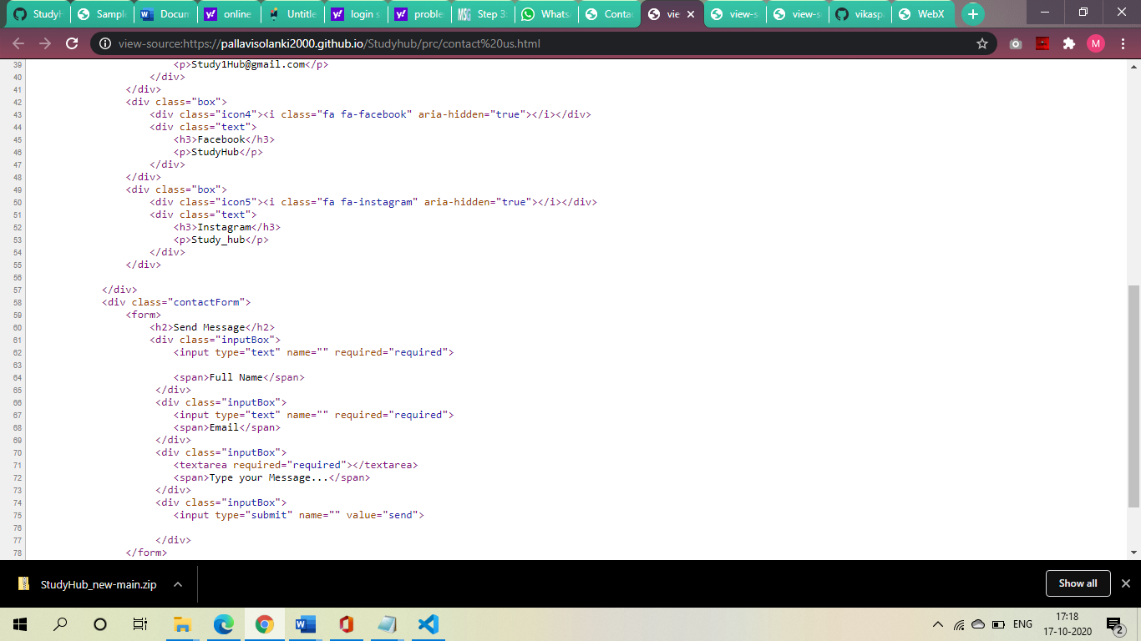

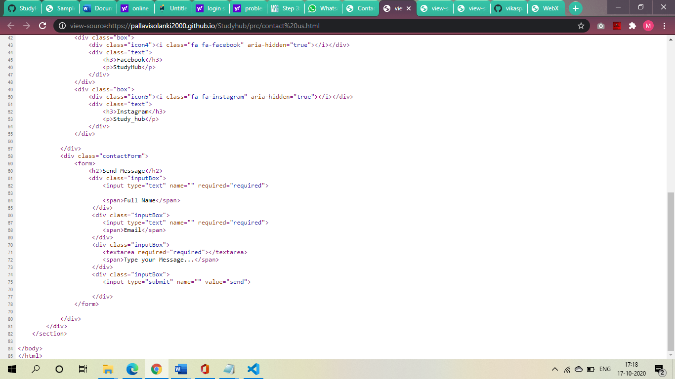

Home

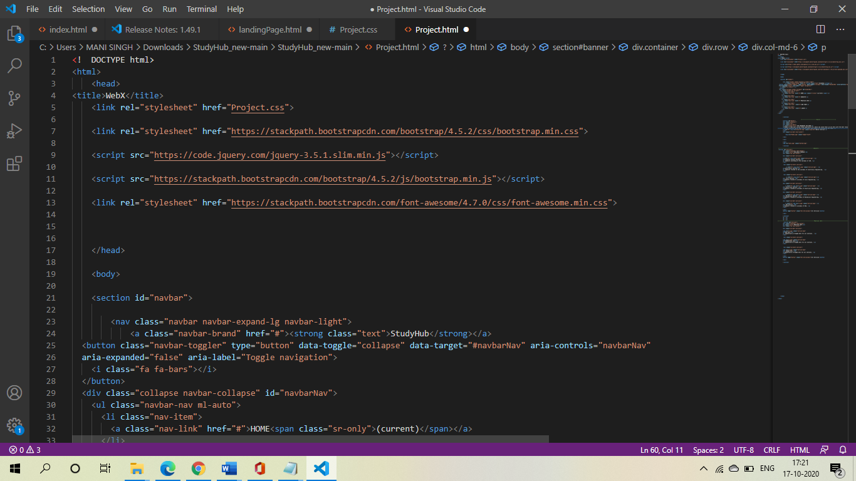

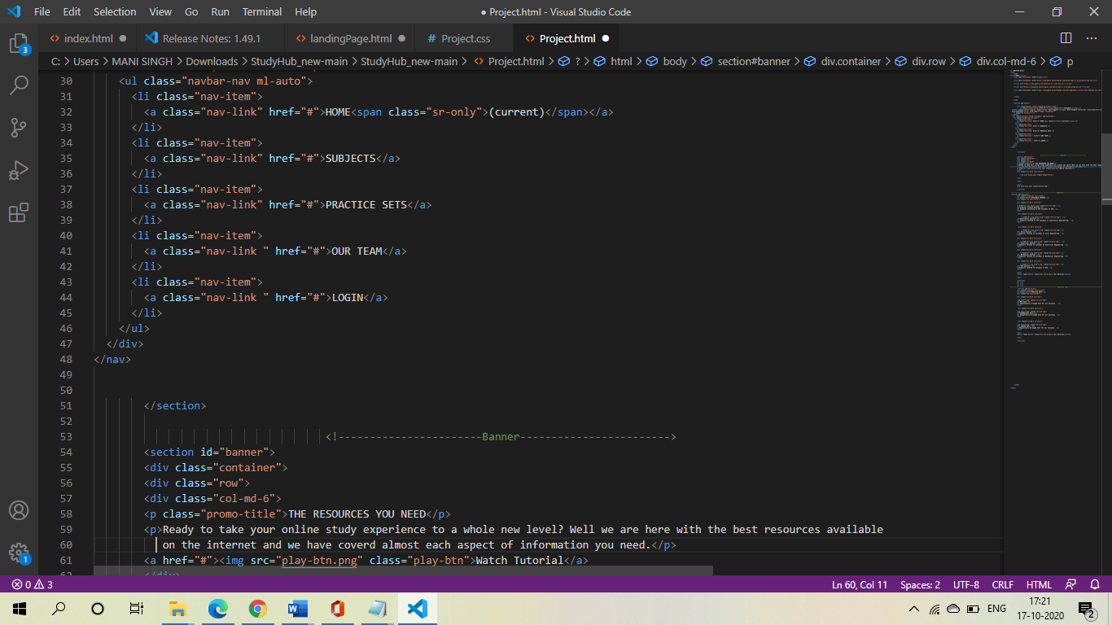

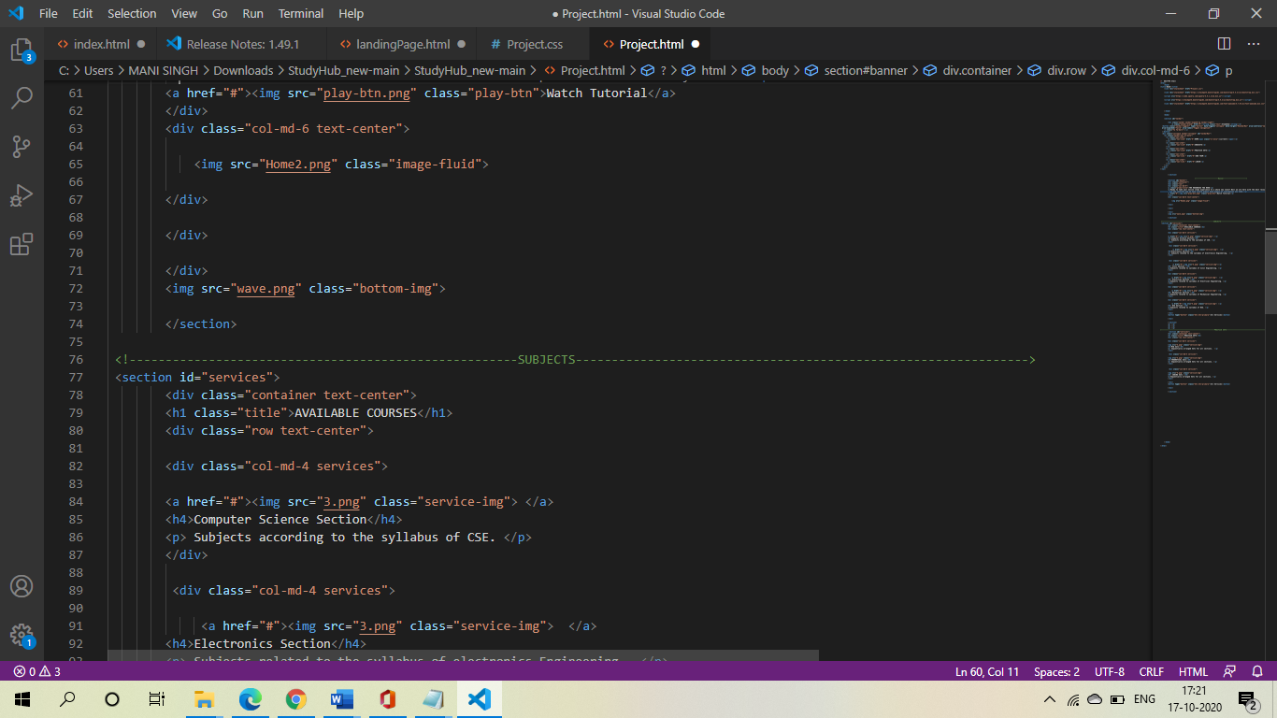

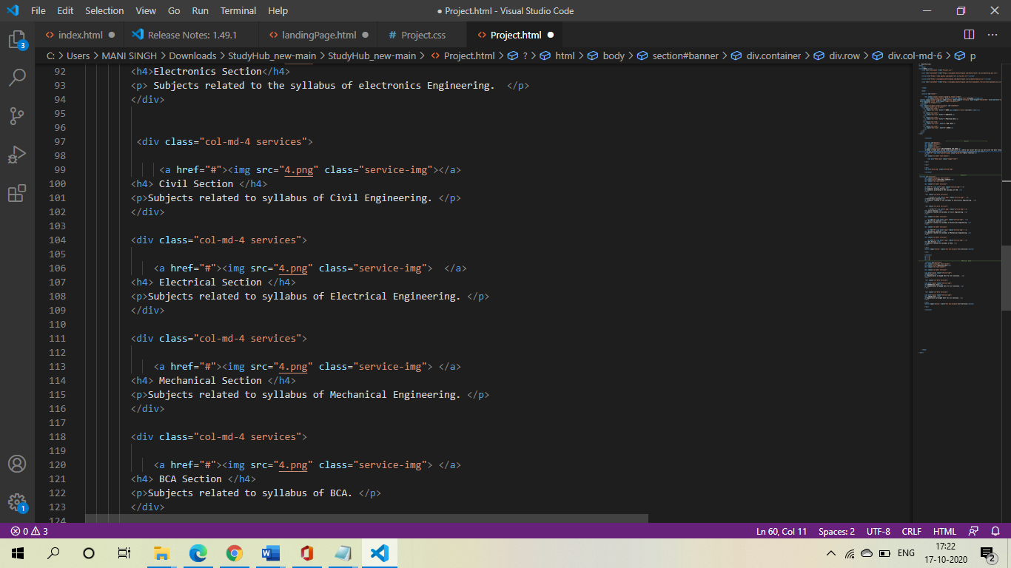

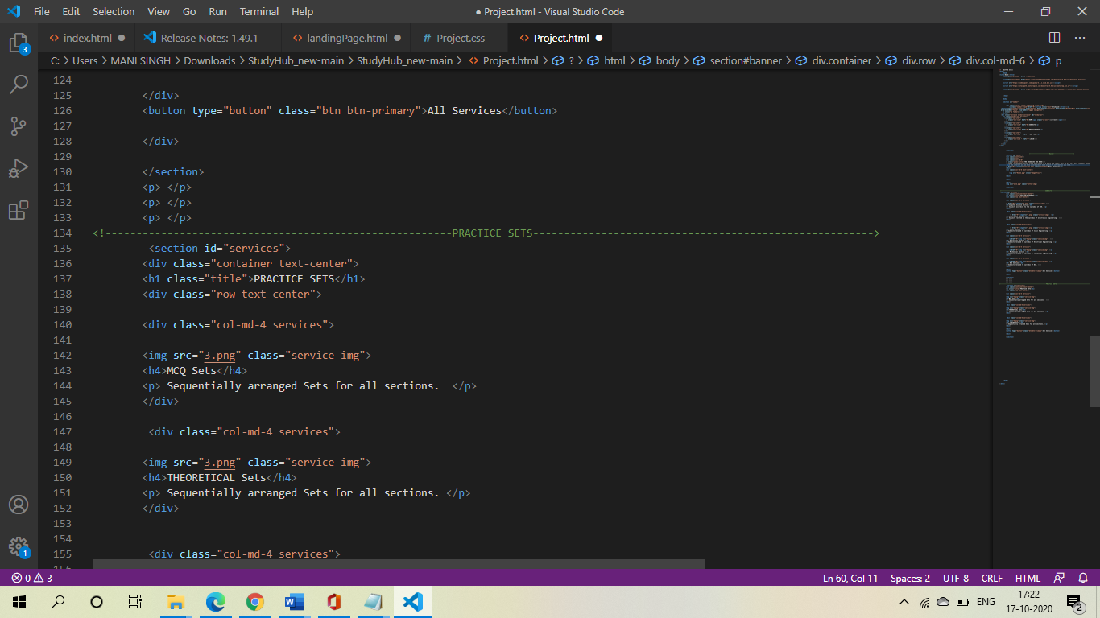

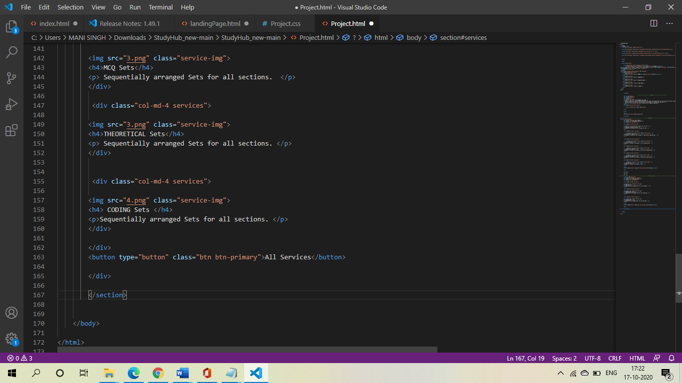

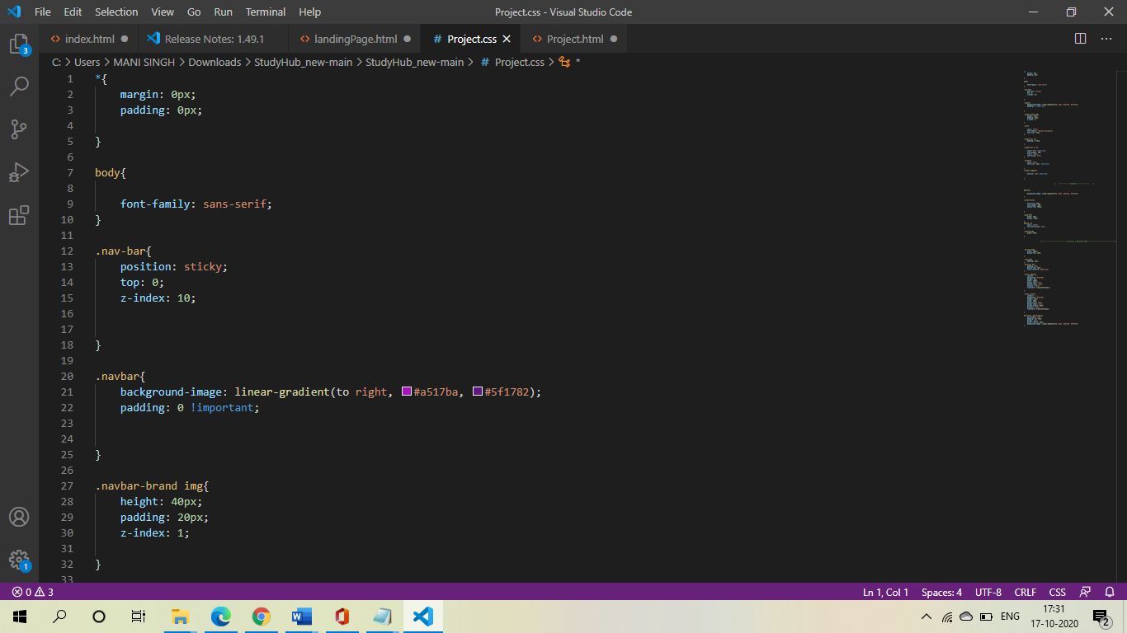

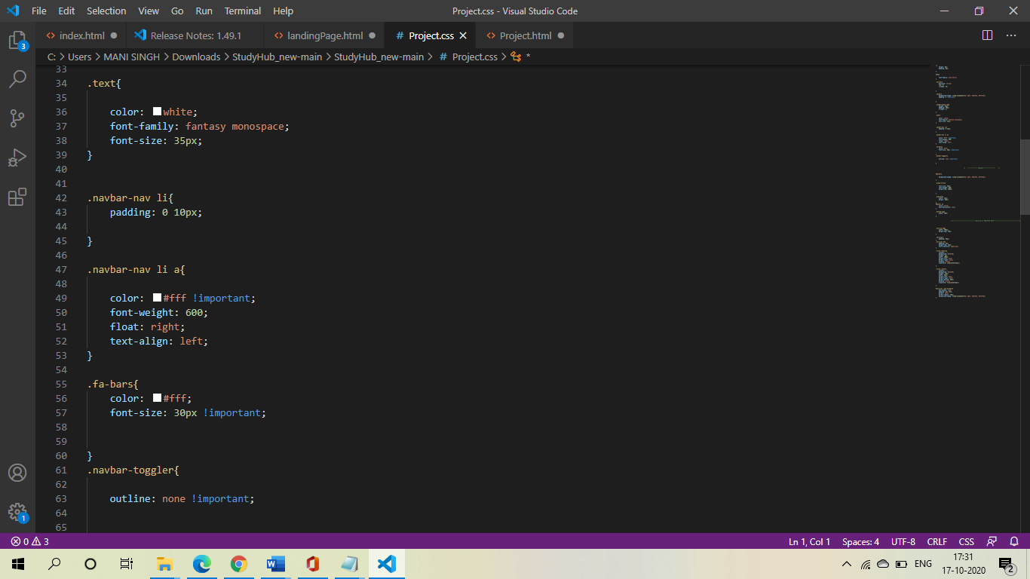

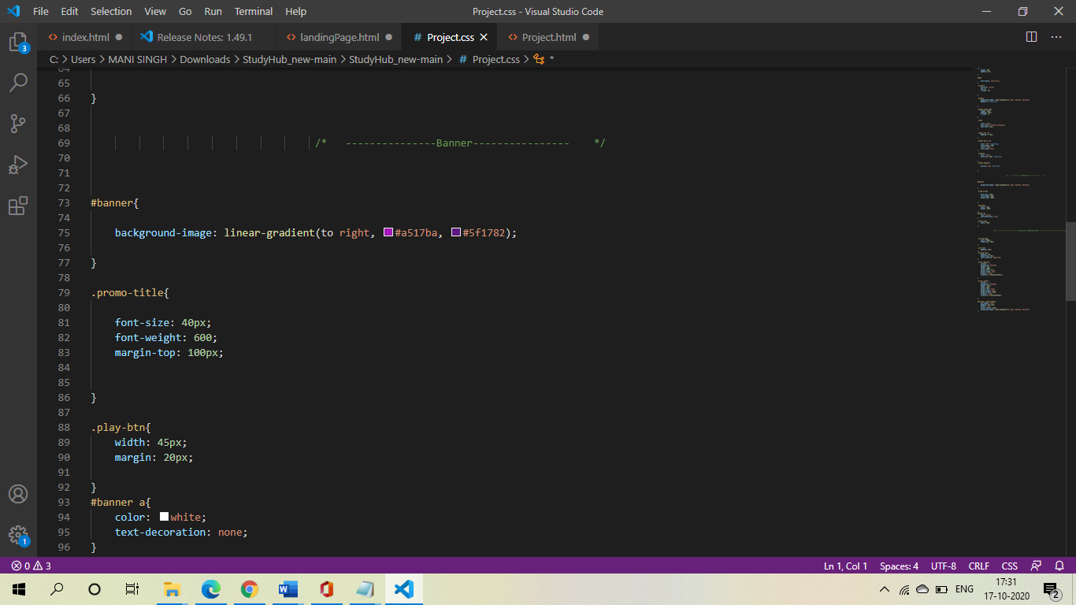

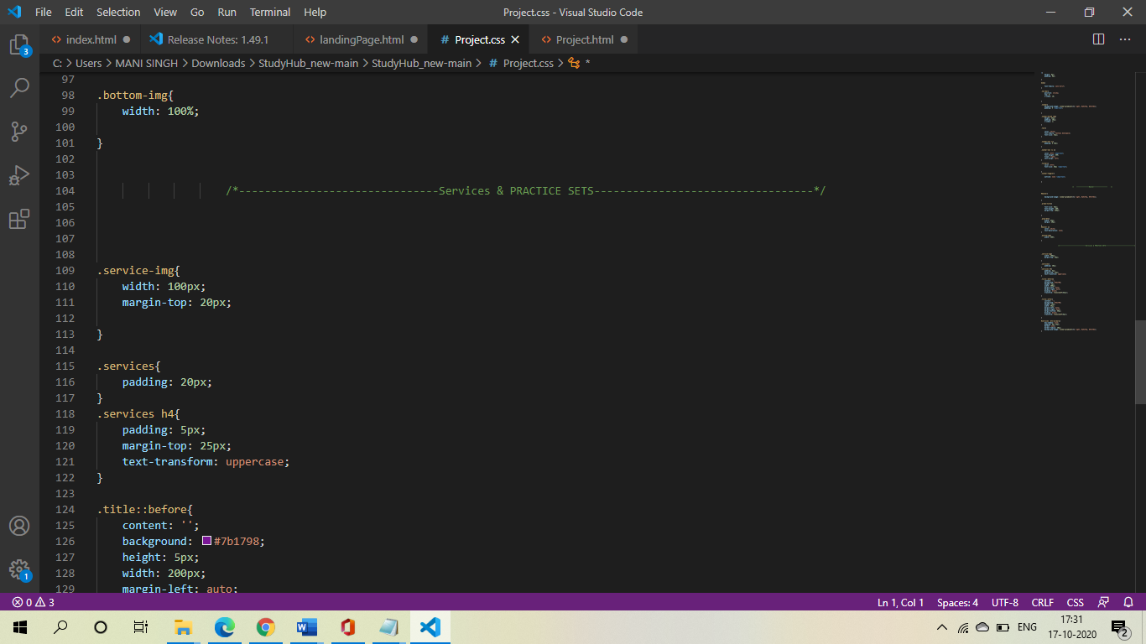

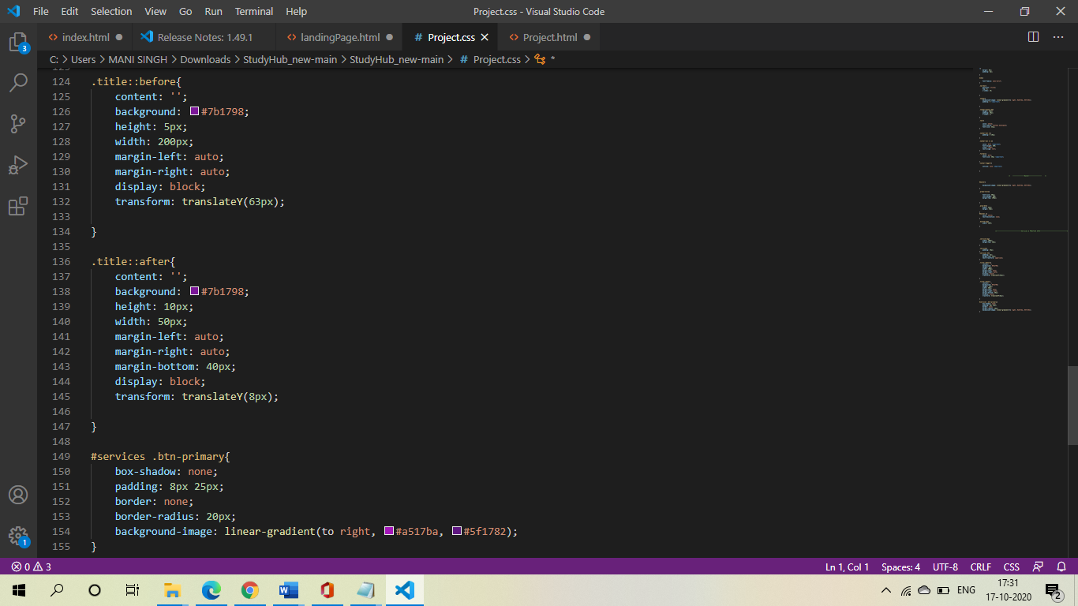

**Reference**

Websites from which we take help from:

* **<https://www.udemy.com/>**
* **<https://www.w3schools.com/>**
* **<https://www.codecademy.com/>**